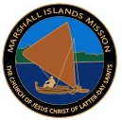
CHOOSE THE HARDER RIGHT Newsletter of the Marshall Islands/Kiribati Mission
June-July 2018

The Rising Tide

Elders and Sisters, we are now half way through 2018 and Sister Larkin and I are so grateful for your efforts to ‘teach repentance and baptize converts’. Our mission continues to rise to new heights in terms of our mission culture.
At recent Zone Conferences in both the Marshall Islands and Kiribati, we discussed the principle that a ‘rising tide lifts all boats’. We have seen this in our mission as you have personally focused on following the Missionary Handbook.
The greatest positive influence upon our mission culture is exact obedience by individual missionaries. The accumulative effect of personal obedience is to cause the ‘tide’ to rise – which lifts us all.
President Ezra Taft Benson referred to the important role of obedience in our lives when he stated:
“The great test of life is obedience to God. “We will prove them herewith,” said the Lord, “to see if they will do all things whatsoever the Lord their God shall command them” (Abr. 3:25).
April General Conference, 1988
The prophet’s statement is applicable to our mission as one of the great ‘tests’ of a mission is obedience – and the great blessings associated with missionary service come from unwavering obedience.
Missionary life can be difficult and challenging at times on a number of levels including physically, emotionally, socially and spiritually. But take heart – those difficulties and challenges can ‘shape’ us and help us become more like our Savior, Jesus Christ.
The scriptures declare: “Though he were a Son, yet learned he obedience by the things which he suffered” (Hebrews 5:8).
Knowing that we would all need His help to navigate life, the Lord promised:
“And whoso receiveth you, there I will be also, for I will go before your face. I will be on your right hand and on your left, and my Spirit shall be in your hearts, and mine angels round about you, to bear you up (D&C 84:88).
May the Lord continue to bless you as you serve Him as a committed and obedient missionary.
President Larkin

May/June Arrivals
TARAWA
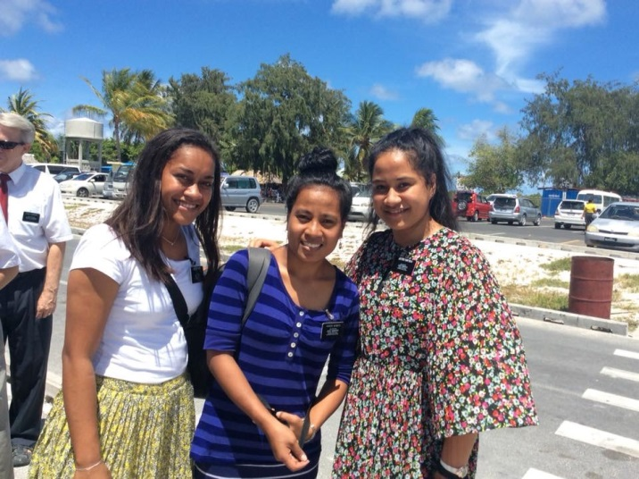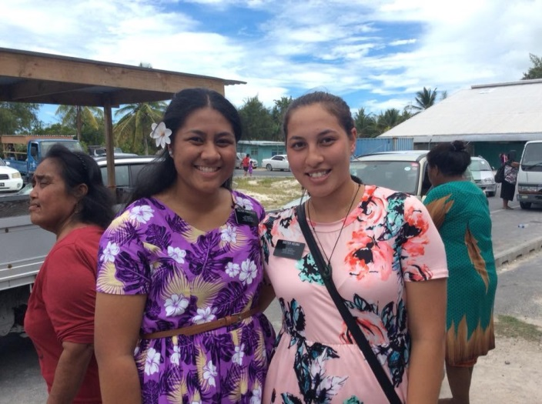
Sister Bosei, Sister Iborito, ands Sister Hafoka Sister Pailegutu and Sister Keung

May/June Departures
TARAWA
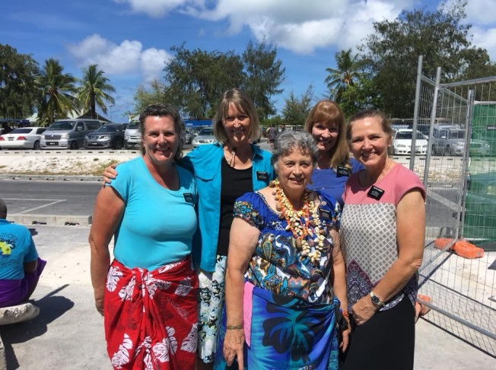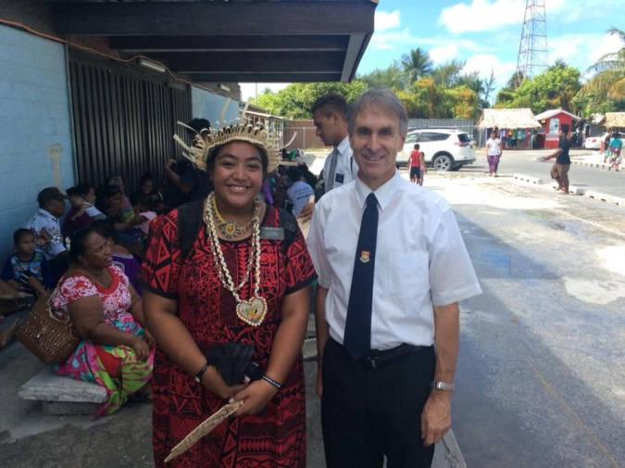
Sister Shumway (Center) Sister Lata
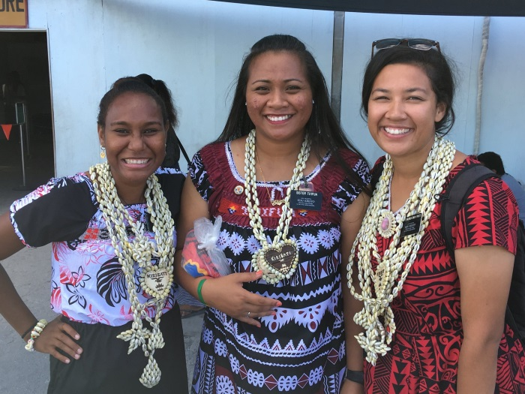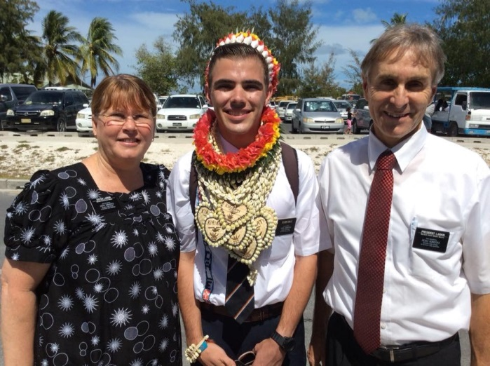
Sister Rome, Sister Tu’ifua and Sister Moungatnga-Fowler Elder Dale

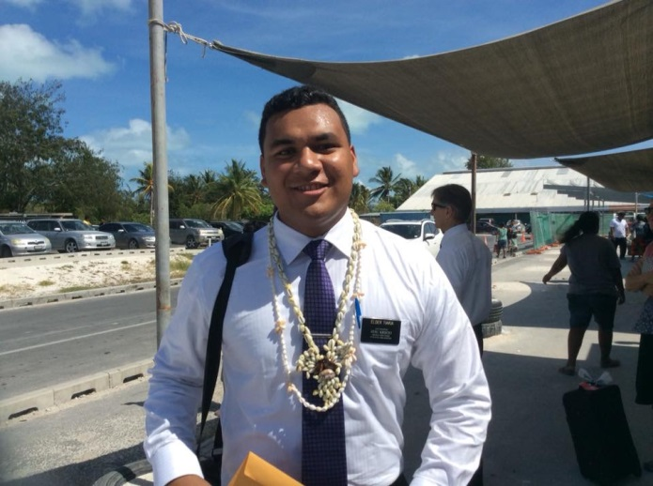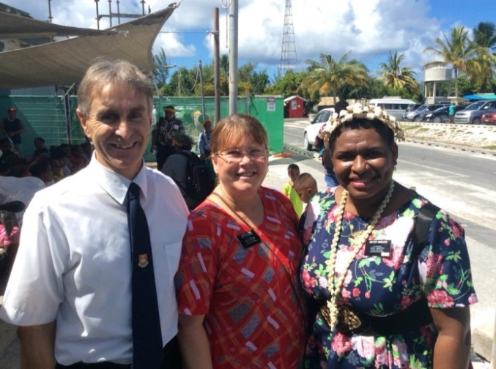
Elder Tiakia Sister kindaro

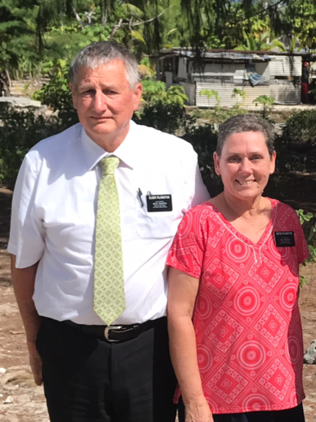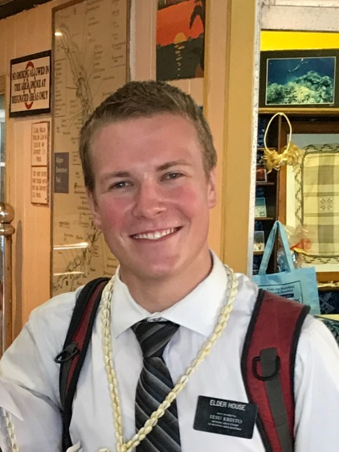
Elder and Sister Pilkington Elder Pratt Elder House

Majuro
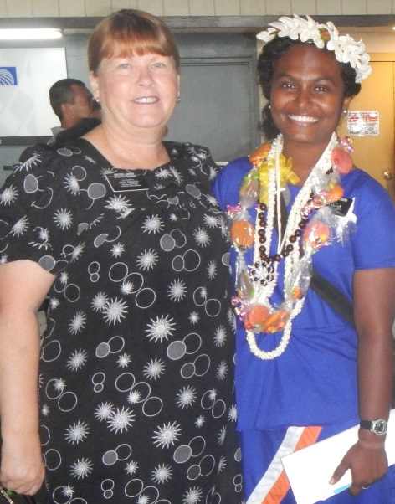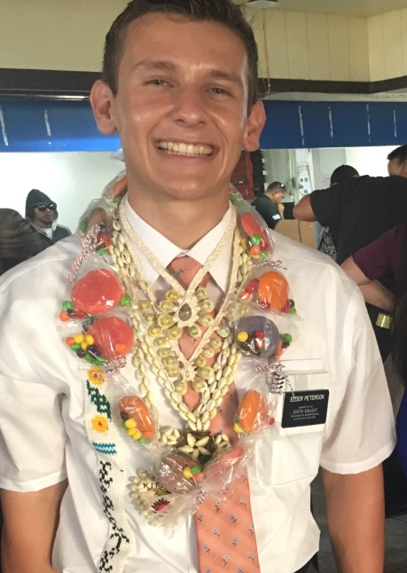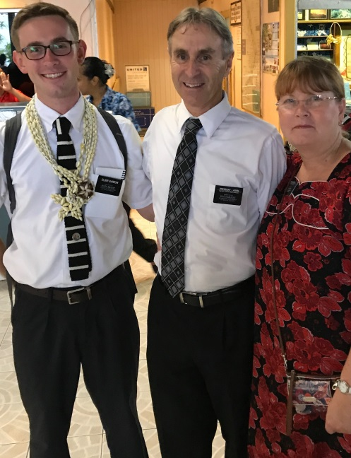
Sister Wilson Elder Peterson Elder Barrow

Birthdays
June July August
02 Sister Paletua K 03 Elder Versoni K 01 Sister Tamite K
03 Elder Barrow M 03 Sister Latu K 04 Elder B. Hansen K
04 Elder Clark K 05 Elder Lander K 05 Sister Naivalu K
04 Elder Tuilagi M 08 Sister Lander K 06 Sister Belshe K
07 Elder Jensen K 08 Sister Bosei K 11 Elder Tuikolovatu K
07 Elder Nebo K 09 Elder Sheffield K 11 Elder Roberts K
09 Elder Anderson M 10 Elder L. Hansen M 11 Elder Payne K
10 Elder Gilmour K 11 Elder Duke K 13 Sister Masoe M
10 Sister Taufa M 11 Sister Menzie K 14 Elder Dunn M
14 Elder Guy K 12 Elder Martin M 16 Elder Jubeck K
14 Elder Toro K 13 Elder Haycock K 16 Elder House M
16 Sister Lutui K 14 Elder Kendrick M 17 Elder Weenig K
21 Elder Scholle K 15 Sister Tamale K 20 Elder Mower M
21 Sister Willis K 06 Elder Tollefson K 21 Elder Gila K
28 Elder Seffker K 17 Elder Seager M 22 Sister Robison K
19 Elder Bradshaw M 23 Elder Meiners K
23 Sister Fuataga ? 26 Elder Waqa M
25 Elder Boiteux K 27 Elder Anani K
26 Elder Feinga M
28 Sister Kitekeiaho M
28 Elder Hanks K
31 Elder Menzie K

Current Events

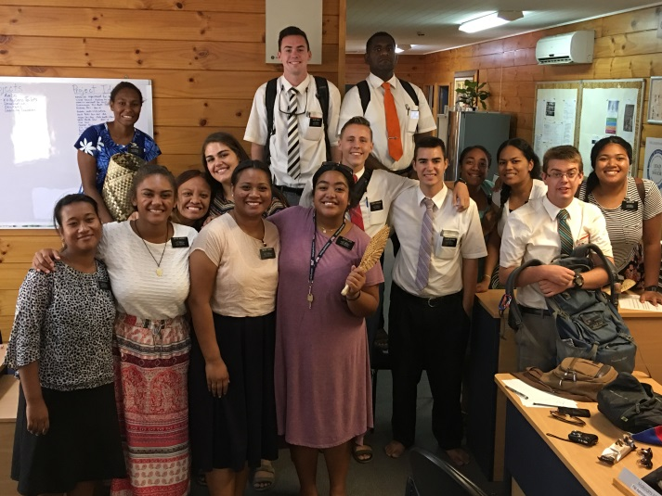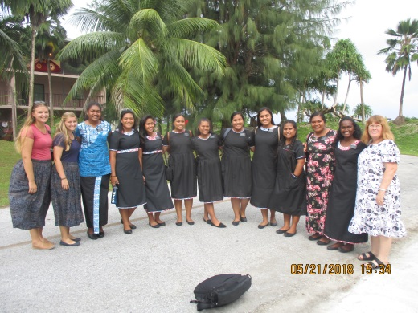
Mother’s Day Skype Calls Sister’s at Zone Conference

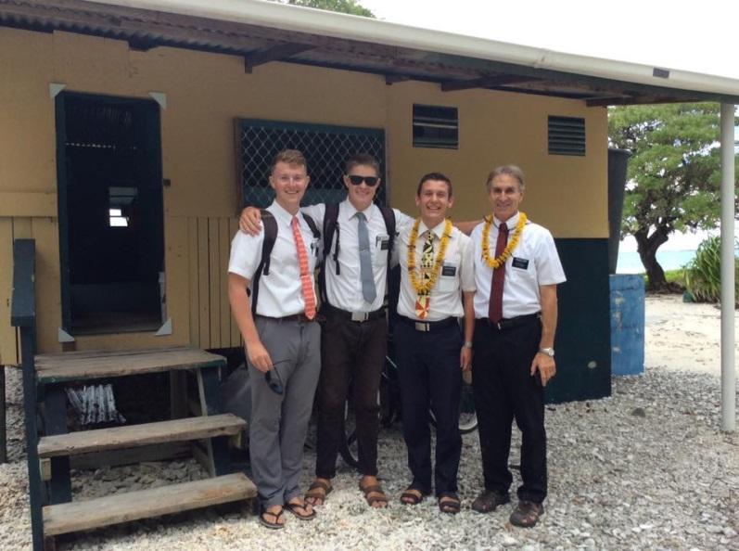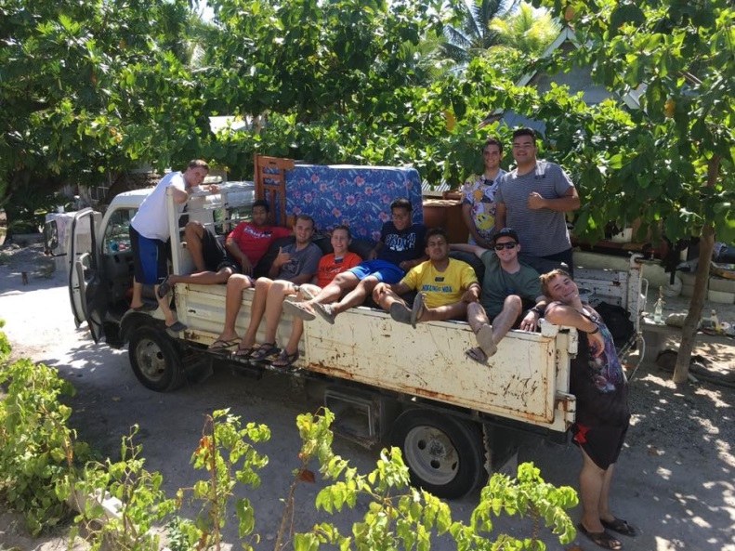
Outer Island’s Helping with a move

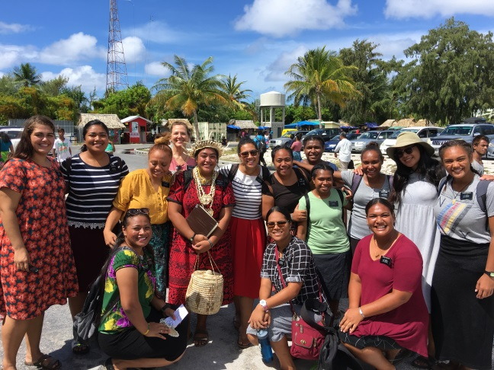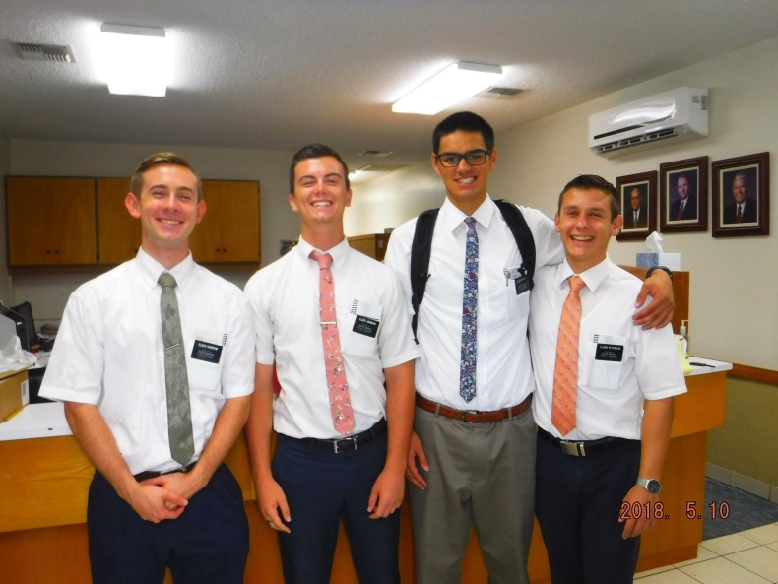
Sisters at airport farewell Office Visit

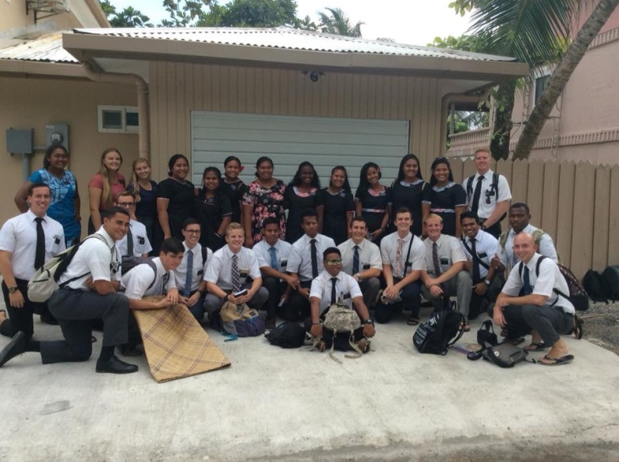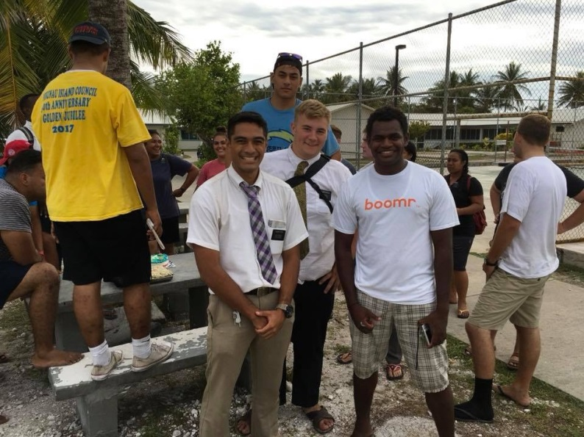
Majuro Zone Conference P-day at Moroni High

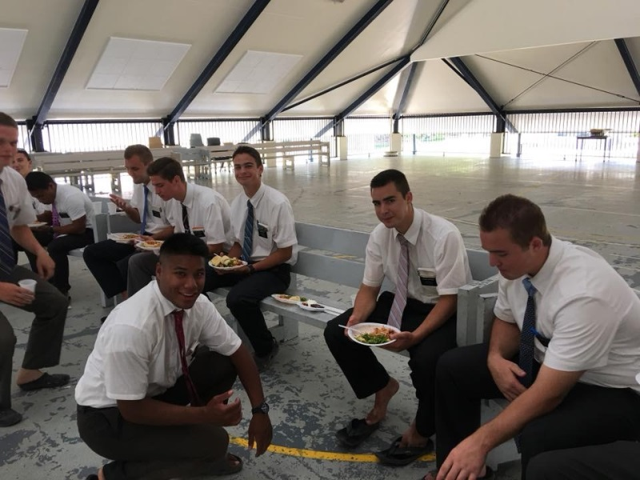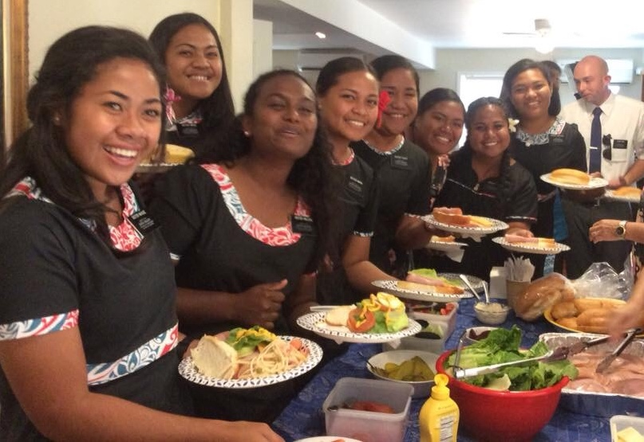
Tarawa Zone Conference Majuro Zone Conference

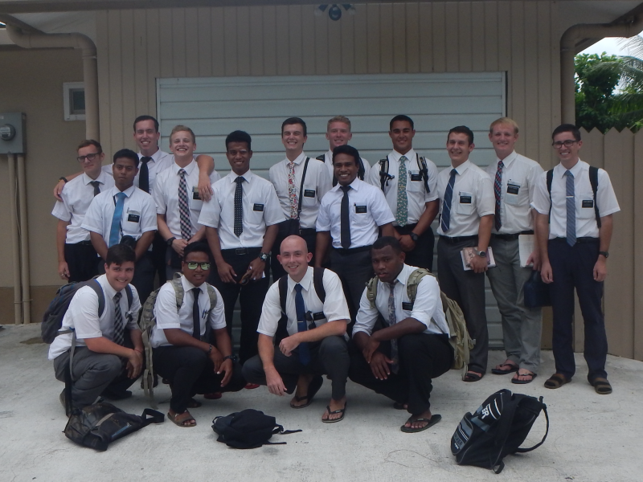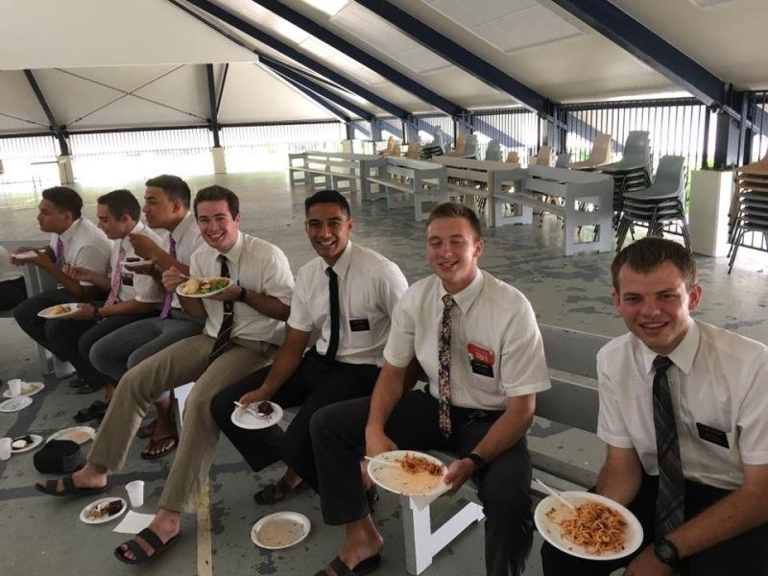
Majuro Elders- Zone Conference Tarawa Elders- Zone Conference

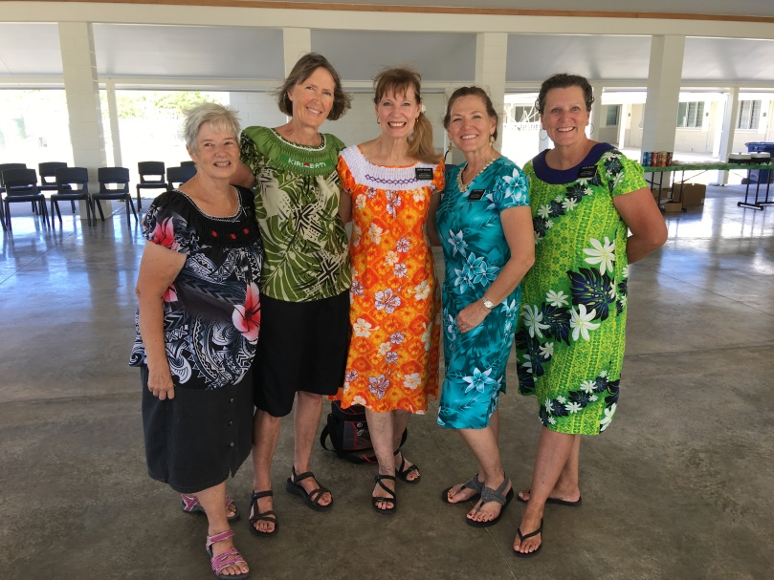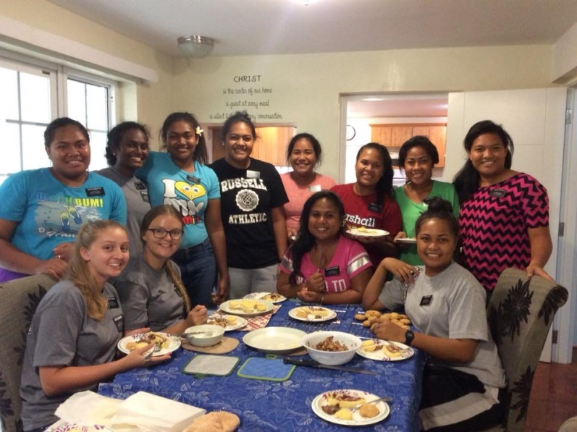
Tarawa Senior Sisters Sister’s P-day with Sister Larkin

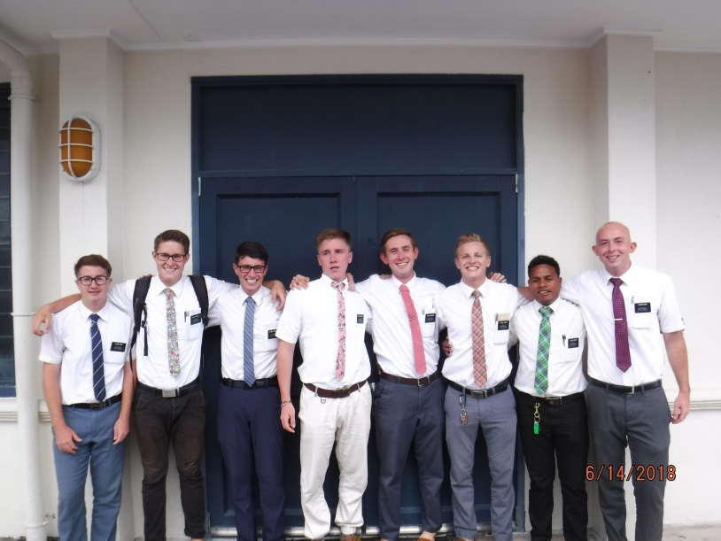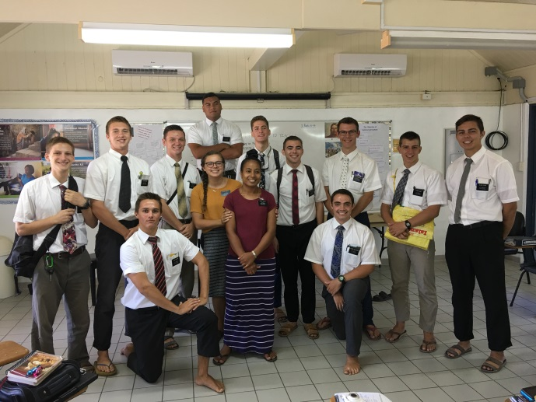
Stake Conference Ambo District Meetings

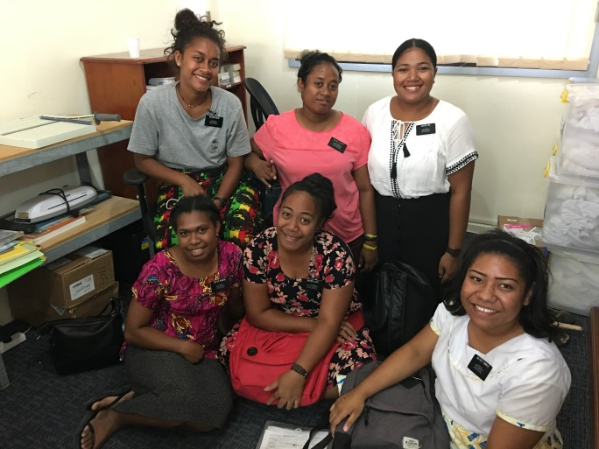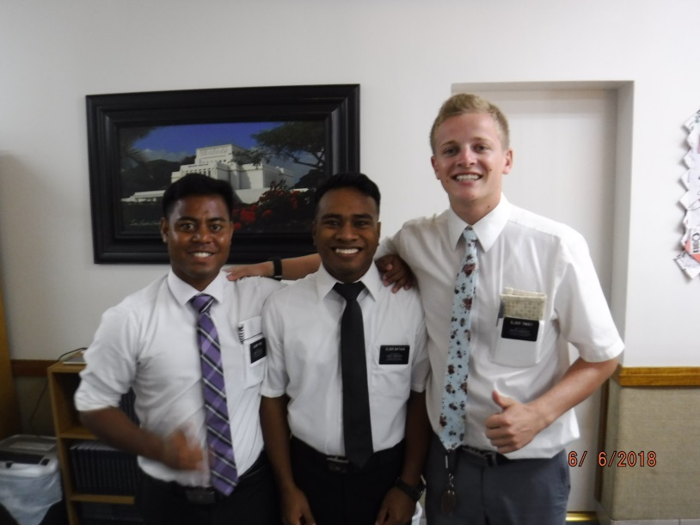
Interview Day at office Office Visit
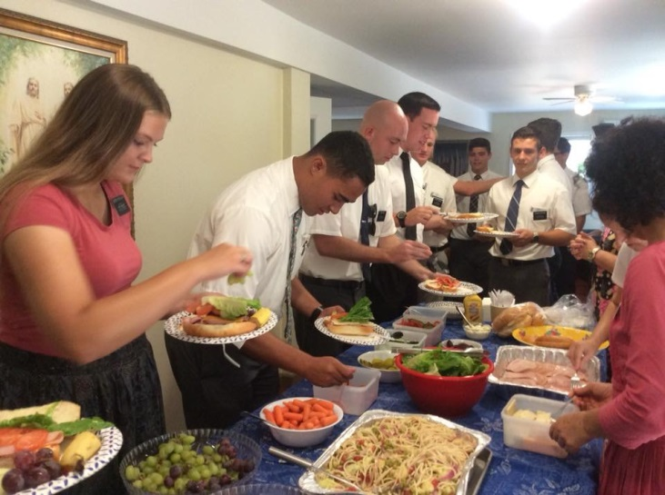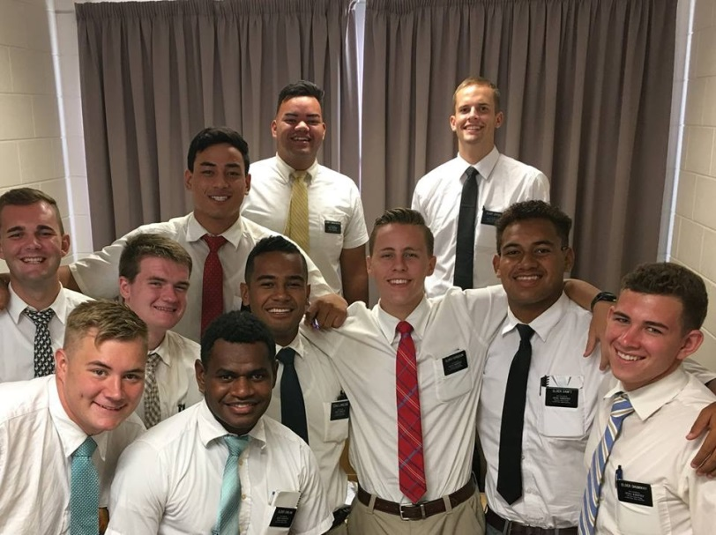
Zone Conference Temiku District meeting

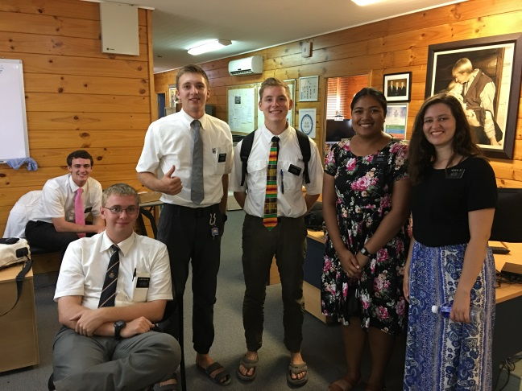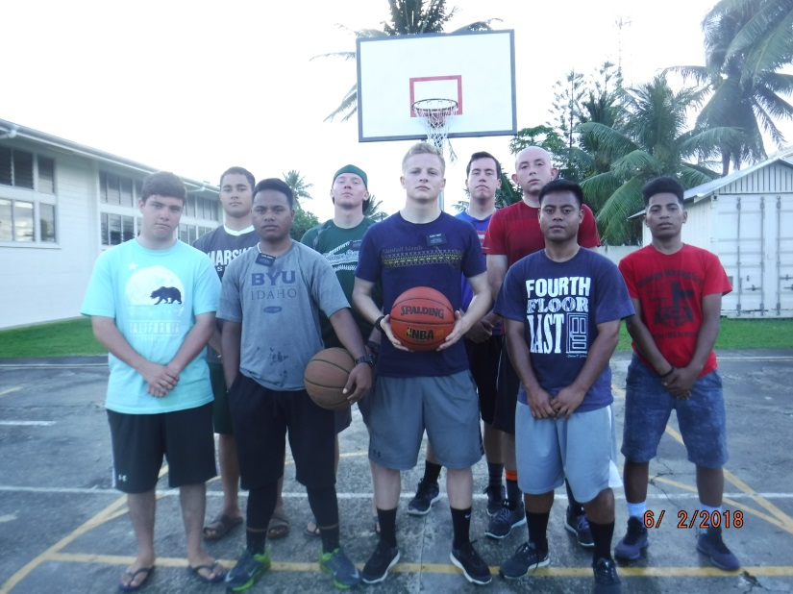
Mother’s Day Skype Calls Majuro p-day

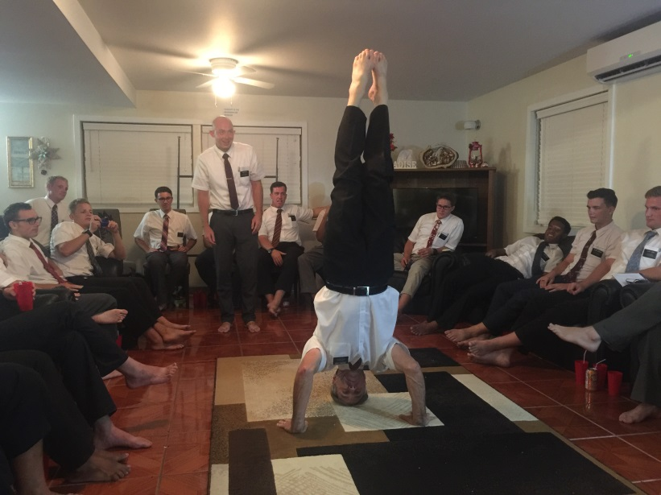 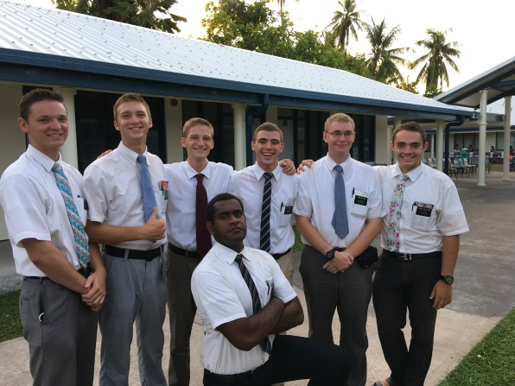 Elder’s night- Pres. Larkin headstand Ambo District Elders

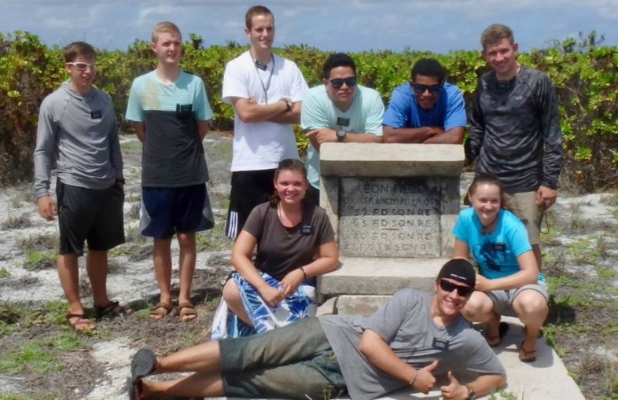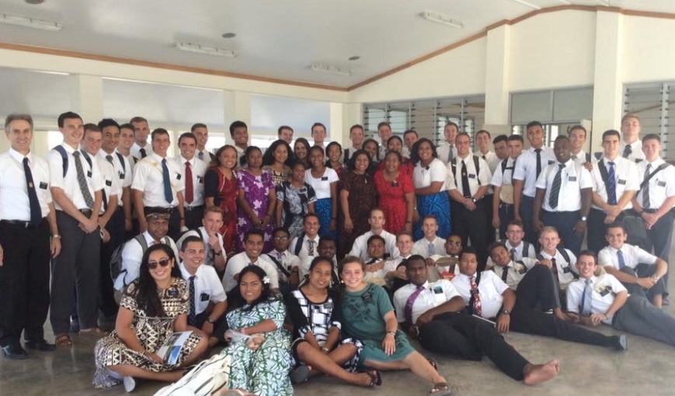
Kritimati P-day Tawawa Zone Conference

Baptisms
Betio 2 Long Island
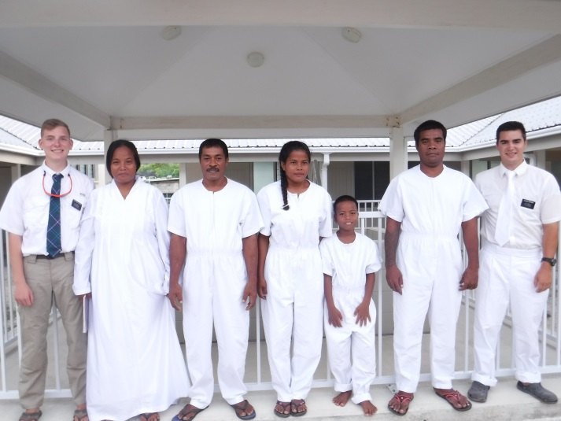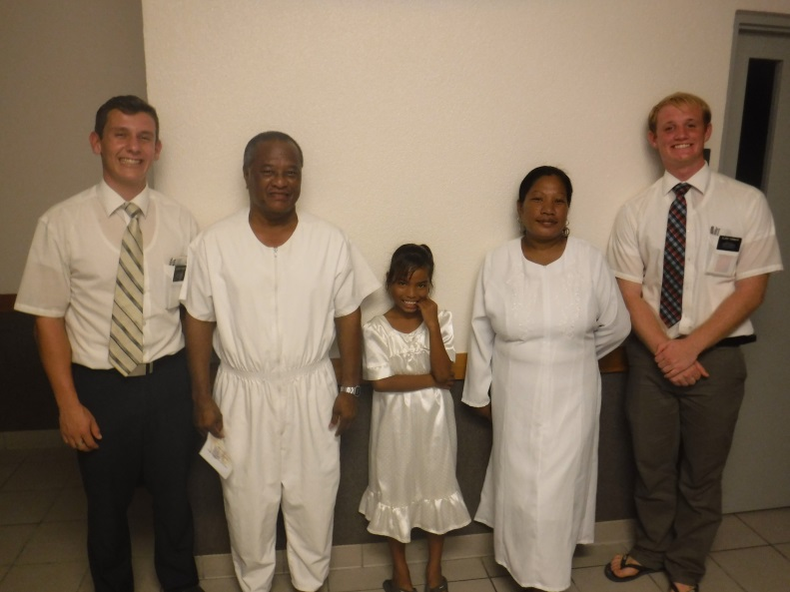
Elder Seffker and Elder Breckenridge Elder Peterson and Elder Turnbow

Rita Teaoraereke 2
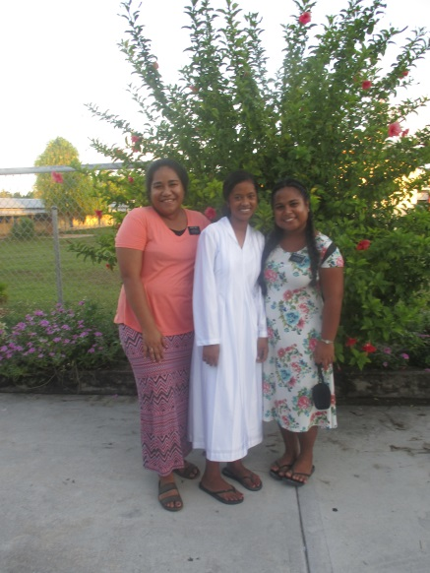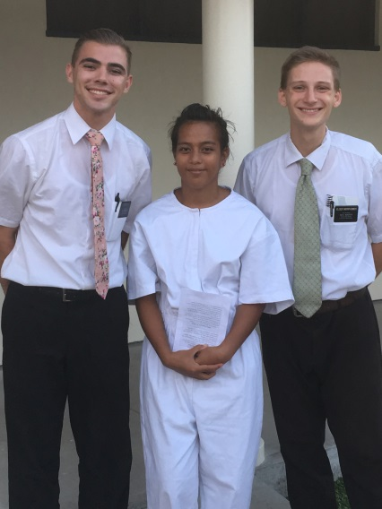
Sister Taufa and Sister Kaotirake Elder Dale and Elder Morphonios

Mosiah 18:10-11
10 Now I say unto you, if this be the desire of your hearts, what have ye against being baptized in the name of the Lord, as a witness before him, that ye have entered into a covenant with him, that ye will serve him and keep his commandments, that he may pour out his Spirit more abundantly upon you?
11 And now when the people had heard these words, they clapped their hands for joy, and exclaimed: This is the desire of our hearts.
Laura Teaoraereke 2
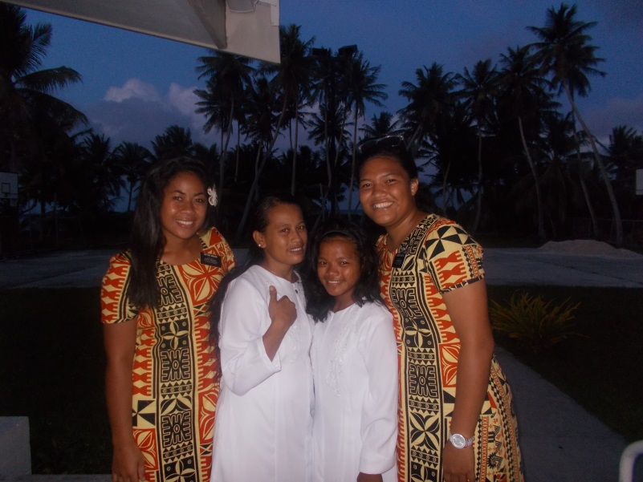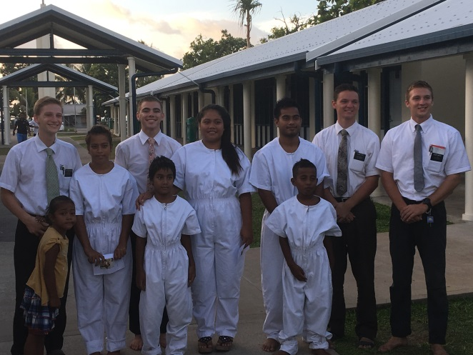
Sister masoe and Sister Tautua’a Elder Morphonios, Elder Dale, Elder Jubeck and Elder Otto

Betio 2 Long Island
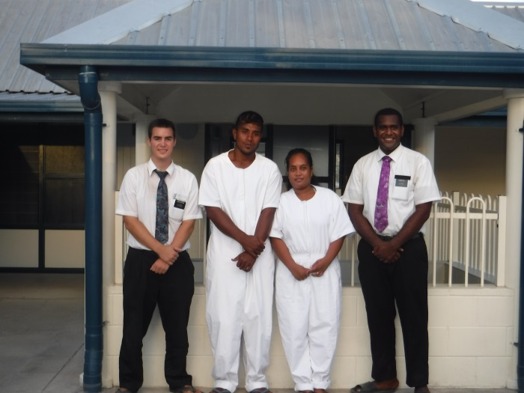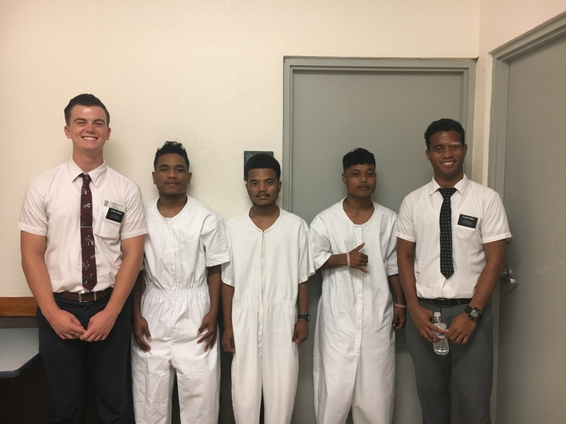
Elder Seffker and Elder Gila Elder Johnson and Elder Kainga
Jaluit
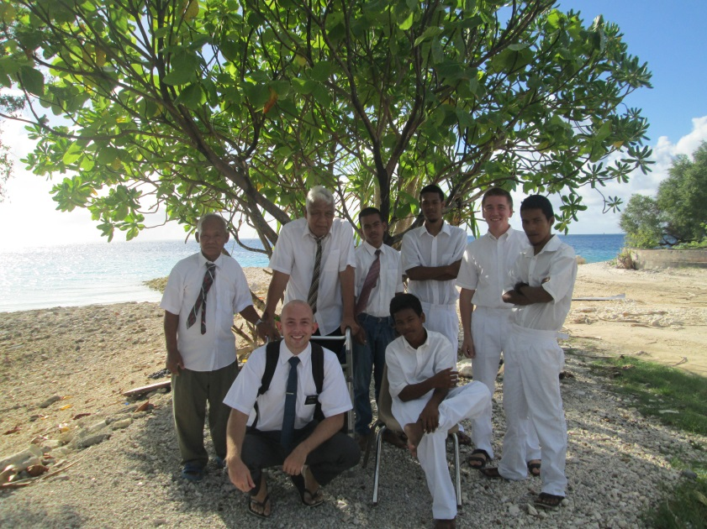
Elder Dunn and Elder Hansen

